**East West University**

**Department of CSE**

**LAB REPORT**

|  |  |  |
| --- | --- | --- |
| **Course Code and Name:**  CSE209 Electrical Circuits | | |
| **Datasheet no: 06** | | |
| **Experiment name:**  Verification of Thevenin’s theorem | | |
| **Semester and Year:**  Fall 2021 |  | |
| **Name of Student:**  D.M. Rafiun – Bin -Masud | **Course Instructor information:**  M Saddam Hossain Khan  Senior Lecturer, Department of Computer Science and Engineering | |
| **Student Id:**  2019-3-60-137 |
| **Date of Report Submitted:**  22 December,2021 | **Pre-Lab Marks:** |  |
| **Post Lab Marks:** |  |
| **TOTAL Marks:** |  |

|  |  |  |  |  |  |  |  |
| --- | --- | --- | --- | --- | --- | --- | --- |
| Measured  Value of *E*1 | Measured  Value of *E*2 | Measured  Value of  *V*L | Measured  Value of *I*L | Measured value of  *V*OC | Measured  value of *I*SC | Measured values  resistors  (k) | of |
| 10V | 5V | 3.26mA | 3.26 V | 7.089V | 6.034mA | *R*1 = 1k  *R*2 = 3.3k  *R*3 = 4.7k  *R*4 = 1k  *RL* = 1k |  |

**Table 1.** Experimental Datasheet for determining Thevenin’s equivalent circuit.

|  |  |  |  |
| --- | --- | --- | --- |
| *E*th = *V*OC | *R*th = *V*OC/*I*SC | Measured Value of *V*L | Measured Value of *I*L |
| 7.089V | 1.175KΩ | 3.26V | 3.26mA |

**Table 2.** Experimental Datasheet for Thevenin’s equivalent circuit.

**Circuit Diagrams:**

Figure 1:

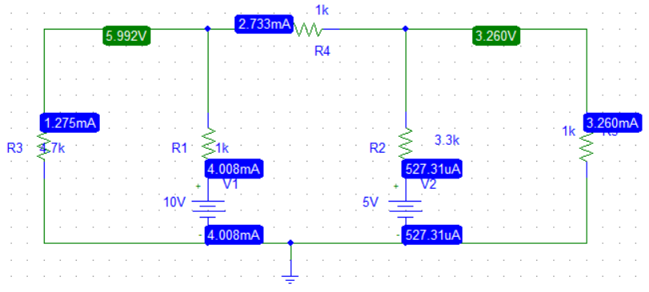

Figure 2:

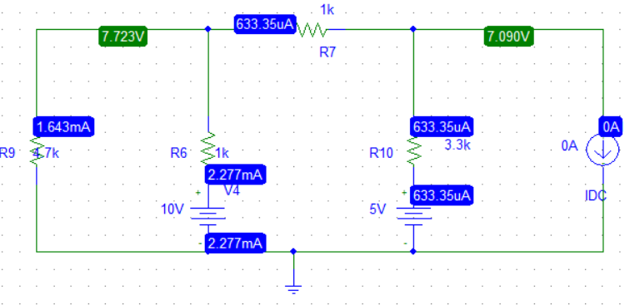

Figure 3:

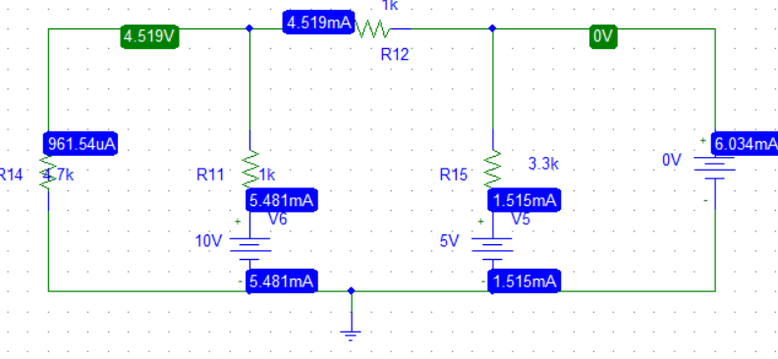

Figure 4:

